**Automation Package Steps**

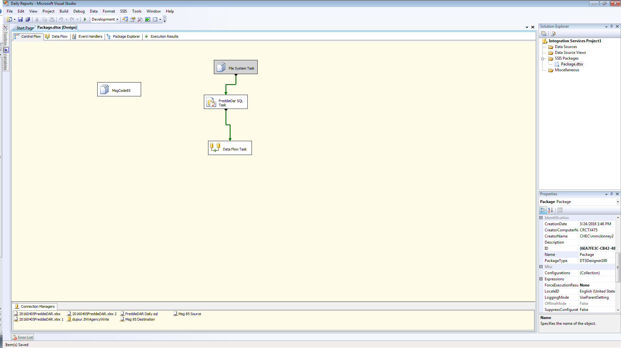

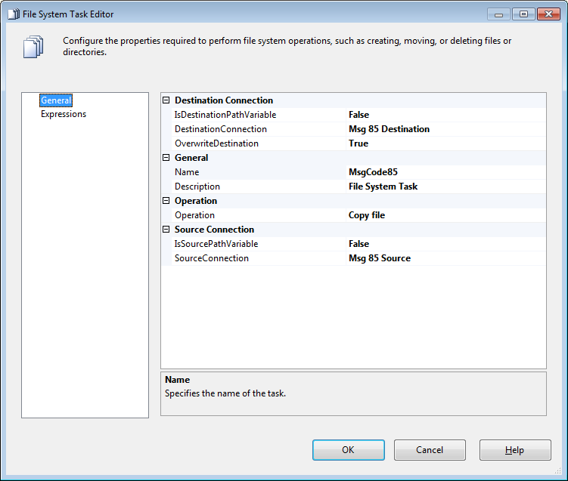



**MSG 85 Destination:** \\vrisi01\users$\mmckinney2\windows\Desktop\DestinationFolder\04-06-2016BK_ACTIVE_WITH_MSG_CODE_85.xls

**MSG 85 Source:** L:\DR\1-Daily Production Processes\Bankruptcy\BK_ACTIVE_WITH_MSG_CODE_85.xlsx

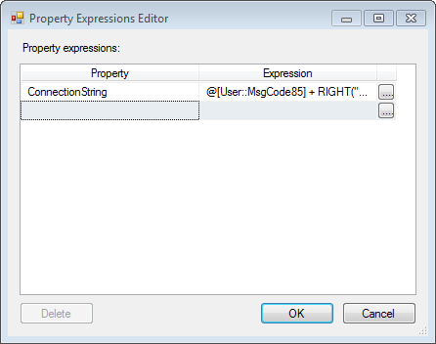

@[User::MSGCODE85_D]+ RIGHT("0"+(DT_WSTR,2)MONTH(GETDATE()),2) + "-"+ RIGHT("0"+(DT_WSTR,2)DAY(GETDATE()),2) + "-"+ (DT_WSTR,4)YEAR(GETDATE()) + "BK_ACTIVE_WITH_MSG_CODE_85" + ".xls"

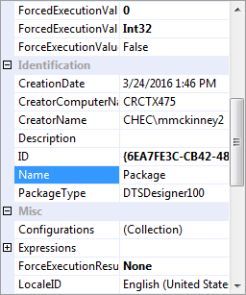

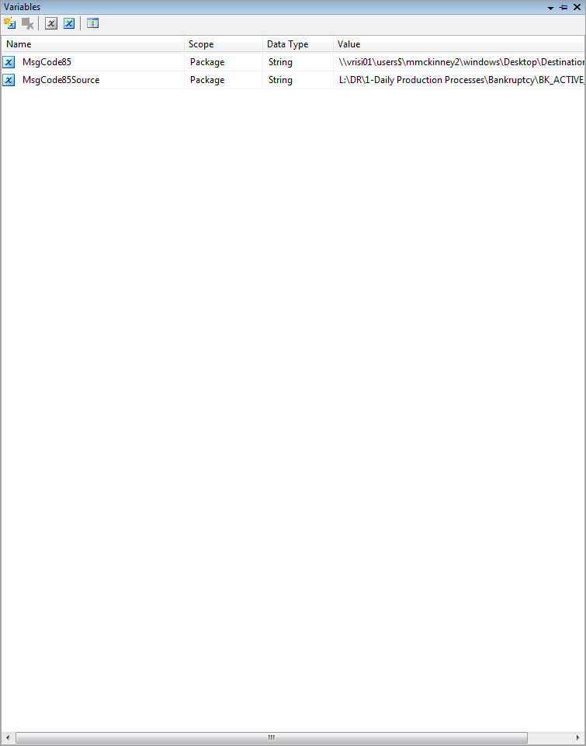

BKExceptionsDestination

BkExceptionsSource

**Variables**

**MSG CODE 85**

@[User::MSGCODE85_D]+ RIGHT("0"+(DT_WSTR,2)MONTH(GETDATE()),2) + "-"+ RIGHT("0"+(DT_WSTR,2)DAY(GETDATE()),2) + "-"+ (DT_WSTR,4)YEAR(GETDATE()) + "BK_ACTIVE_WITH_MSG_CODE_85" + ".xls"

**Case Number Control**

@[User::CASENUMBERCONTROL_D] + RIGHT("0"+(DT_WSTR,2)MONTH(GETDATE()),2) + "-"+ RIGHT("0"+(DT_WSTR,2)DAY(GETDATE()),2) + "-"+ (DT_WSTR,4)YEAR(GETDATE()) + " Case_Number_Control " + ".xls"

**Closed LSAMS Opens LPS**

@[User::CL_LS_OPENLPS_D]+ RIGHT("0"+(DT_WSTR,2)MONTH(GETDATE()),2) + "-"+ RIGHT("0"+(DT_WSTR,2)DAY(GETDATE()),2) + "-"+ (DT_WSTR,4)YEAR(GETDATE()) + " Closed_ LSAM_ Opens_ LPS " + ".xls"

**BK Exceptions**

@[User::BKExceptions_D]+ RIGHT("0"+(DT_WSTR,2)MONTH(GETDATE()),2) + "-"+ RIGHT("0"+(DT_WSTR,2)DAY(GETDATE()),2) + "-"+ (DT_WSTR,4)YEAR(GETDATE()) + " BK_EXCEPTIONS" + ".xls"

**BK Last Payment > 6 months**

@[User::BK_LASTPAY_6M_D] + RIGHT("0"+(DT_WSTR,2)MONTH(GETDATE()),2) + "-"+ RIGHT("0"+(DT_WSTR,2)DAY(GETDATE()),2) + "-"+ (DT_WSTR,4)YEAR(GETDATE()) + " BK_Last_Payment6_months "+ ".xls"

**BK_Late_Charges**

@[User::LATE_CHARGES_D]+ RIGHT("0"+(DT_WSTR,2)MONTH(GETDATE()),2) + "-"+ RIGHT("0"+(DT_WSTR,2)DAY(GETDATE()),2) + "-"+ (DT_WSTR,4)YEAR(GETDATE()) + " BK_Late_Charges"+ ".xls"

**MSGCODE17**

@[User::BK_MSG_CODE_17_D]+ RIGHT("0"+(DT_WSTR,2)MONTH(GETDATE()),2) + "-"+ RIGHT("0"+(DT_WSTR,2)DAY(GETDATE()),2) + "-"+ (DT_WSTR,4)YEAR(GETDATE()) + " BK_MSG_CODE_17_PRIOR_DAY" + ".xls"

**BK OPEN BKFD_Dest**

@[User::BK_OPEN_BKFD_COMMENTS_D]+ RIGHT("0"+(DT_WSTR,2)MONTH(GETDATE()),2) + "-"+ RIGHT("0"+(DT_WSTR,2)DAY(GETDATE()),2) + "-"+ (DT_WSTR,4)YEAR(GETDATE()) + " BK_OPEN_BKFD" + ".xls"

**Open LSAM Closed LPS**

@[User::OPENLSAM_CLOSEDLPS_D]+ RIGHT("0"+(DT_WSTR,2)MONTH(GETDATE()),2) + "-"+ RIGHT("0"+(DT_WSTR,2)DAY(GETDATE()),2) + "-"+ (DT_WSTR,4)YEAR(GETDATE()) + " BK_OPEN_LSAM_CLOSED_LPS" + ".xls"

**PPDD_EXCEPTIONS_D**

@[User::PPDD_EXCEPTIONS_D] + RIGHT("0"+(DT_WSTR,2)MONTH(GETDATE()),2) + "-"+ RIGHT("0"+(DT_WSTR,2)DAY(GETDATE()),2) + "-"+ (DT_WSTR,4)YEAR(GETDATE()) + " BK_PPDD_EXCEPTIONS" + ".xls"

**PRO SE CHECK**

@[User::PROSECHEC_D] + RIGHT("0"+(DT_WSTR,2)MONTH(GETDATE()),2) + "-"+ RIGHT("0"+(DT_WSTR,2)DAY(GETDATE()),2) + "-"+ (DT_WSTR,4)YEAR(GETDATE()) + " BK_PRO_ SE_ CHECK" + ".xls"

**SETUP_VALIDATION_D**

@[User::SETUP_VALIDATION_D]+ RIGHT("0"+(DT_WSTR,2)MONTH(GETDATE()),2) + "-"+ RIGHT("0"+(DT_WSTR,2)DAY(GETDATE()),2) + "-"+ (DT_WSTR,4)YEAR(GETDATE()) + " BK_SETUP_VALIDATION" + ".xls"

**BK_SURRENDERED_PROPERTIES_D**

@[User::BK_SURRENDERED_PROPERTIES_D] + RIGHT("0"+(DT_WSTR,2)MONTH(GETDATE()),2) + "-"+ RIGHT("0"+(DT_WSTR,2)DAY(GETDATE()),2) + "-"+ (DT_WSTR,4)YEAR(GETDATE()) + " BK_SURRENDERED_PROPERTIES" + ".xls"

**PDX_Exceptions_D**

@[User::PDX_Exceptions_D] + RIGHT("0"+(DT_WSTR,2)MONTH(GETDATE()),2) + "-"+ RIGHT("0"+(DT_WSTR,2)DAY(GETDATE()),2) + "-"+ (DT_WSTR,4)YEAR(GETDATE()) + " PDX_BK_PAYCHANGE_NOTICE_EXCEPTIONS " + ".xls"

**PDX_Complete_D**

@[User::PDX_Complete_D]+ RIGHT("0"+(DT_WSTR,2)MONTH(GETDATE()),2) + "-"+ RIGHT("0"+(DT_WSTR,2)DAY(GETDATE()),2) + "-"+ (DT_WSTR,4)YEAR(GETDATE()) + " BK_PDX_COMPLETE" + ".xls"

**PDX_OPEN_D**

@[User::PDX_OPEN_D] + RIGHT("0"+(DT_WSTR,2)MONTH(GETDATE()),2) + "-"+ RIGHT("0"+(DT_WSTR,2)DAY(GETDATE()),2) + "-"+ (DT_WSTR,4)YEAR(GETDATE()) + "BK_PDX_OPEN_PROCESS" + ".xls"

**CORP ADV_EXCEPTIONS_D**

@[User::BK_CORP_ADV_EXCEPTIONS_D] + RIGHT("0"+(DT_WSTR,2)MONTH(GETDATE()),2) + "-"+ RIGHT("0"+(DT_WSTR,2)DAY(GETDATE()),2) + "-"+ (DT_WSTR,4)YEAR(GETDATE()) + " BK_CORP_ADV_EXCEPTIONS" + ".xls"

**DAILY_DASHBOARD_D**

@[User::DAILY_DASHBOARD_D] ]+ RIGHT("0"+(DT_WSTR,2)MONTH(GETDATE()),2) + "-"+ RIGHT("0"+(DT_WSTR,2)DAY(GETDATE()),2) + "-"+ (DT_WSTR,4)YEAR(GETDATE()) + " BK_DAILY_DASHBOARD_D " + ".xls"

**LOB Pipeline_D**

@[User:: LOB_PIPELINE_D]+ RIGHT("0"+(DT_WSTR,2)MONTH(GETDATE()),2) + "-"+ RIGHT("0"+(DT_WSTR,2)DAY(GETDATE()),2) + "-"+ (DT_WSTR,4)YEAR(GETDATE()) + " LOB_PIPELINE" + ".xls"

**DAILY KPI**

@[User::BK_DAILY_KPI_D]+ RIGHT("0"+(DT_WSTR,2)MONTH(GETDATE()),2) + "-"+ RIGHT("0"+(DT_WSTR,2)DAY(GETDATE()),2) + "-"+ (DT_WSTR,4)YEAR(GETDATE()) + "BK_DAILY_KPI" + ".xls"

**MSG CODE 43 Escalations**

@[User::BK_MSG_43_D]]+ RIGHT("0"+(DT_WSTR,2)MONTH(GETDATE()),2) + "-"+ RIGHT("0"+(DT_WSTR,2)DAY(GETDATE()),2) + "-"+ (DT_WSTR,4)YEAR(GETDATE()) + " MSG CODE 43 Escalations" + ".xls"

**DEBT_ATTY_ADDR_D**

@[User::DEBT_ATTY_ADDR_D]+ RIGHT("0"+(DT_WSTR,2)MONTH(GETDATE()),2) + "-"+ RIGHT("0"+(DT_WSTR,2)DAY(GETDATE()),2) + "-"+ (DT_WSTR,4)YEAR(GETDATE()) + " DEBT_ATTY_ADDR_D" + ".xls"

**PCN_IN_120_D**

@[User:: PCN_IN_120_D]+ RIGHT("0"+(DT_WSTR,2)MONTH(GETDATE()),2) + "-"+ RIGHT("0"+(DT_WSTR,2)DAY(GETDATE()),2) + "-"+ (DT_WSTR,4)YEAR(GETDATE()) + " PCN_IN_120_D" + ".xls"

**Freddie_Dar**

@[User::DestinationFolder]+"RegionalCustomer_"+Replace(Replace(Substring((DT_WSTR,30)GETDATE(),1,16),":","_"),"-","_")+".xlsx"

**(Proper code format)**

**@[User::PIPELINE_D]**

@[User::BK_PIPELINE_D]+ RIGHT("0"+(DT_WSTR,2)MONTH(GETDATE()),2) + "-"+ RIGHT("0"+(DT_WSTR,2)DAY(GETDATE()),2) + "-"+ (DT_WSTR,4)YEAR(GETDATE()) + "BK_ PIPELINE" + ".xls"

